**AvantiGas Gender Pay Gap Report 20222**

**Creating an inclusive culture**

Here at AvantiGas, we are committed to treating all our people fairly and rewarding them appropriately for their contribution to our organisational goals and successes.

Our Gender Pay Gap Report is just one of the ways we measure our progress and identify opportunities to do better. This is our 5th report and demonstrates further improvement in our performance relating to Gender Pay and equity.

Despite the improvements that we see today, we know that the journey doesn’t stop here. We are committed to working to improve gender equity throughout AvantiGas and make sure all our colleagues are supported.

**What is the Gender Pay Gap?**

The Gender Pay Gap measures and reports on the difference in average hourly pay between all men and women employed by an organisation, regardless of their role or seniority. Organisations with 250 or more employees must report on their gender pay gap figures every year.

The Gender Pay Gap is different to equal pay, which focuses on the difference in pay between men and women who carry out the same or similar jobs, or work of equal value.

**How is the Gender Pay Gap worked out?**

The Gender Pay Gap is measured in two ways – the mean gender pay gap and the median gender pay gap.

The mean gender pay gap is the difference between the average hourly earnings of men and women. A mean average is reached by adding up all the numbers and dividing the result by how many numbers there are.

The median gender pay gap is the difference between men’s and women’s average hourly earnings at the midpoint between the highest and lowest earnings. By using the midpoint between the highest and lowest earnings, the median gender pay gap is a more representative measure of typical earnings.

Hourly pay includes basic pay, allowances and shift premiums, on-call and standby allowances, overtime and sales commission.

**How are we doing at AvantiGas?**

The data and findings in this report are based on a total of 278 relevant employees using snapshot data gathered on 5th April 2022.

**Pay**

The mean gender pay gap The median gender pay gap

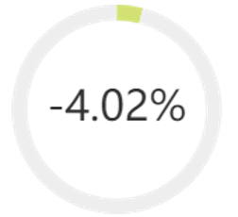 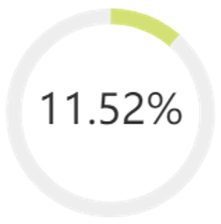

|  |  |
| --- | --- |
| An improvement of 1.2% compared  to 2021 | An improvement of 4.78% compared to 2021 |

**Bonuses**

In 2022, we awarded bonuses to 91.58% of men at AvantiGas and to 86.21% of women.

Women's mean bonus pay is 3.34% more than mens

Women's median bonus pay is 28.10% less than mens

This demonstrates a slight decrease in both the mean figure and median figures; however. We are proud that these results remain significantly better than the national averages.

**Gender Pay Quartiles**

Pay quartiles show the proportion of men and women in each quartile pay band at AvantiGas. This graph shows the data broken down into 4 equally sized groups ranging from the lowest to the highest paid employees. The gender pay gap is widest in the upper middle and upper pay quartile.

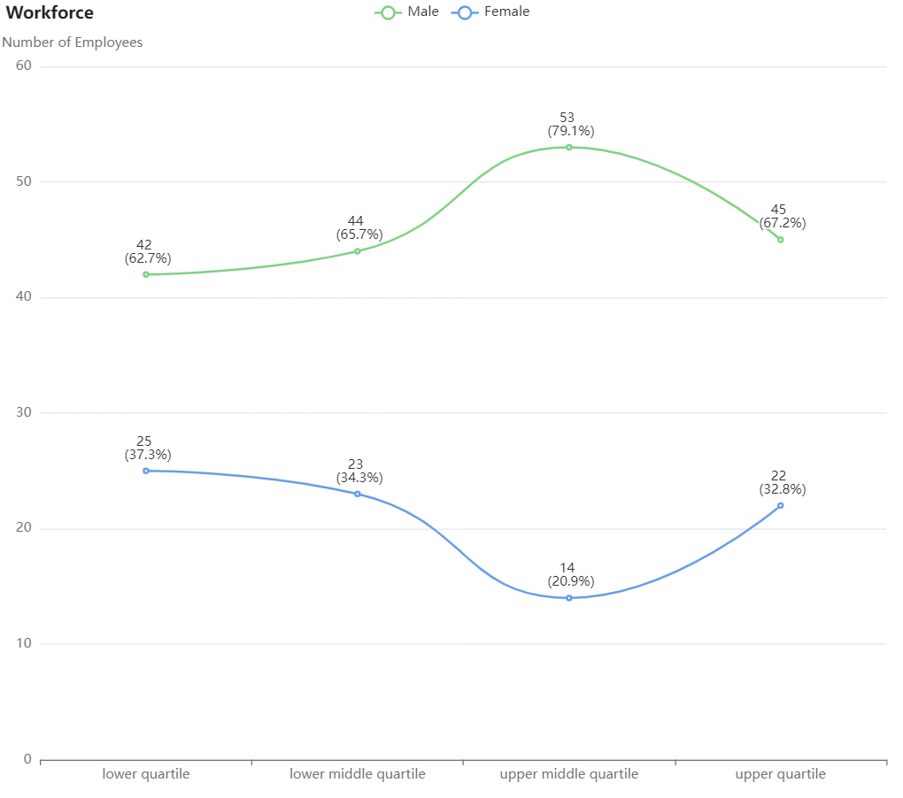

**Behind the numbers**

**Explaining our gender pay gap**

Our findings for 2022 show the continuous impact of the positive steps we have taken to date to close the gender pay gap, however we will continue to maintain our focus on this to make sure that we do not slip.

There was a slight shift in the mean gender pay gap during 2022, with women earning more than men on average but as we know this is only one of the metrics. When we consider the median (mid-point) we still see that a gap exists with men being paid more, however the gap is moving ever closer. This doesn’t mean we’re paying women less than men for doing the same job, but it does show that there are more men in higher paying roles.

We continue to see that operational and technically skilled roles, such as drivers, site operatives and engineers, are populated by men, while office-based roles tend to be populated by women. Operational roles often require specialised skills and qualifications and are usually higher paid as a result, influencing our mean and median gender pay gap. We see the same at management level within our operational teams, where the majority of team leaders, middle managers and experts in logistics and engineering disciplines are men.

Our senior management teams are more diverse and our drive for improvements in diversity and equity continues across the group. This is undoubtably one of the reasons that we have seen positive movements in closing the gender pay gap as more women move into senior and specialist roles. AvantiGas is owned by UGI International, a leading LPG supplier in Europe serving 17 countries and part of the wider global family of UGI Corporation.

**What’s next?**

**Developing an inclusive culture**

We’re committed to treating people fairly and rewarding them appropriately. This means continuing to develop an inclusive workplace where all our people are supported to thrive.

We still need to work on attracting women into roles traditionally populated by male employees and there is no doubt that this is a challenge. This continues to be an area of focus, not just for AvantiGas but across the industry. That said we are delighted to have successful women already working and thriving within these functions and we look forward to welcoming more.

High on our agenda are training and development opportunities to facilitate personal growth and career progression across all business functions. This includes the exciting opportunity to participate in cross functional projects within the regional and international organisation.

Our talent programs are the springboard for future managers and leaders within the local, international, and global organisation. Particular attention is given to ensuring that such programs include diverse talent pools and continue to see more female participants attending the events at international and global level.

**Improving gender diversity through recruitment**

We are committed to improving female representation at a senior level at AvantiGas and understand the importance of doing so for our people, our customers, and our stakeholders. Research shows that greater gender equality at leadership level increases profitably and leads to better business outcomes.

Our candidate attraction methodologies, including work with external recruitment partners, ensure that a diverse group of candidates are identified for such opportunities. Promising results are evident with this initiative and we are pleased to report that more than 50% of senior recruitments within the group have been awarded to women.

There is no doubt that we face a challenge to attract more women into the industry, especially into roles traditionally occupied by men, and at more senior levels within the organisation. However, there are exciting opportunities for change, with the energy sector playing a pivotal role as the UK moves towards a greener, low carbon economy. Around 400,000 people will need to be recruited into the industry over the next 30 years to help achieve the UK government’s net-zero goals.

Understanding these challenges and opportunities will help us identify how we can improve gender diversity through recruitment.

**Retention and progression**

As well as hiring great talent – we will continue to focus our efforts on retaining great talent and providing opportunities for all our people to thrive, grow and develop, personally and professionally.

We work hard to ensure we maintain high levels of employee satisfaction and develop and motivate everyone in line with their talents, business goals and aspirations.

We have modernised our approach to the work environment, recognising that agile working enables our employees to continue to contribute to strong business performance whilst enabling a better work life balance and focus on family; something greatly appreciated by our female population.

**In conclusion**

2022 has been another challenging year for us all. More flexible, people-centred ways of working are helping to attract more women but the buoyant recruitment markets mean that we have to focus on retaining the talent that we have for the future.

We acknowledge the transition to a low carbon economy has the potential to transform the industry and bring more women into a diverse range of roles traditionally dominated by men and we truly believe that a diverse workforce will be essential in a sector that needs to innovate and grow.

We take great pride in every single one of our people and value their importance to make our business successful. Our Gender Pay Gap Report will help us build on the improvements we’ve made to improve gender diversity at AvantiGas, and put in place our action plan for change.